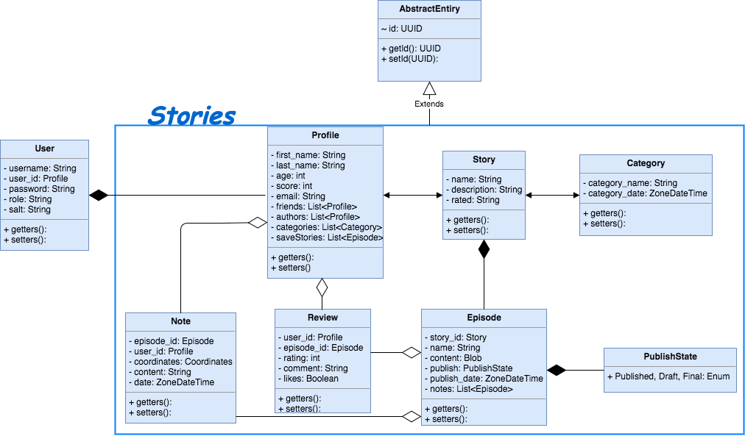

Rest Services

CategoryService:

* createCategory(Category)
* deleteCategory(String)
* updateCategory(Category)
* getCategories(): List<Category>
* getCategory(String): Category

UserService:

* createUser(User): boolean
* changePassword(User, String)
* changeRole(User, String): boolean

ProfileService:

* updateProfileCategories(List<Category>): boolean
* updateProfileFriend(List<Profile>): boolean
* updateProfileAuthor(List<Profile>): boolean
* createProfile(Profile): boolean
* updateProfile(Profile): boolean
* getUserCategories(Profile)
* getUserFriends(Profile)
* getUserAuthors(Profile)
* saveUserStory()+delete->save stories for later

StoryService:

* createStory(Story)
* updateStory(User, Story): boolean
* deleteStory(User, String): boolean
* addEpisode(Episode): boolean
* updateEpisode(User, Episode): boolean
* deleteEpisode(User, Episode): boolean
* addEpisodeNote(Note, Episode): boolean
* updateEpisodeNote(Node, Episode): boolean
* deleteEpisodeNote(User, String): boolean
* getStory(story_id)
* getEpisode(episode_id)
* getEpisodeNotes(Episode)
* getEpisodeNote(note_id)
* getStoryCategories()

ReviewService:

* getReviews(Episode): List<Review>
* getReviews(Profile): List<Review>
* addReview(Review, Episode): boolean
* updateReview(Review, Episode): boolean
* deleteReview(User, String): boolean

Service Layer

FileParser

* parseFile(Inputstream): String

CompressUtil

* compressText(String): byte[]
* decompressText(byt[]): String